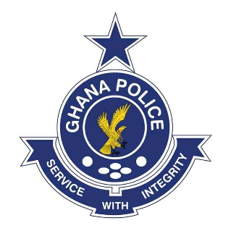

In case of reply the

number and date of this

letter should be quoted

My Ref: PAD/PRESS/VOL.4/1/
Your Ref:

PUBLIC AFFAIRS DIRECTORATE
POLICE HEADQUARTERS
POST OFFICE BOX 116
ACCRA
3RD NOVEMBER, 2025

PRESS RELEASE

IGP DIRECTS CID HEADQUARTERS TO TAKE OVER INVESTIGATION INTO ATTACK ON NAIMOS DIRECTOR AND HIS TEAM AT HWIDIEM: ASUTIFI NORTH MP INVITED TO ASSIST THE INVESTIGATION

The Inspector-General of Police (IGP), Mr. Christian Tetteh Yohuno, has directed the Criminal Investigations Department (CID) Headquarters to take over investigations into the attack on the Director of Operations of the National Anti-Illegal Mining Operations Secretariat (NAIMOS) and his team by thugs at Hwidiem in the Ahafo Region.

The Member of Parliament for Asutifi North, Hon. Ebenezer Kwaku Addo, who is alleged to have incited the mob and obstructed the NAIMOS team has been invited to assist ongoing investigation into the incident.

Preliminary investigation has established that on Saturday, 1st November 2025, the NAIMOS Director and his team intercepted illegal miners operating near Bronikrom in the Ahafo Region and arrested some suspects. Exhibits retrieved from them include a side-hang bag containing one (1) Smith & Wesson pistol, two (2) pistol magazines, twenty-one (21) rounds of 9mm ammunition, an unregistered Range Rover vehicle, an unregistered Toyota RAV4 vehicle and several mobile phones. While the team were preparing to hand over the suspects to the Hwidiem Police Station, the MP reportedly arrived with a group of men and demanded their release. When his demand was refused, the group forcibly removed the suspects’ handcuffs and chased the NAIMOS team from the scene.

A mob numbering about 600, allegedly incited by the MP, later besieged the Hwidiem Police Station demanding the release of the miners and seized vehicles. The crowd vandalized the Director’s vehicle, damaged parts of the police station, and threatened to set it ablaze. Reinforcement teams from the Ahafo Regional Command were deployed to restore order and prevent further destruction.

Calm was eventually restored through the joint efforts of the police, the military, and the Zongo Chief of Hwidiem, who helped mediate the situation and facilitate the safe evacuation of the NAIMOS team. The Chief’s vehicle was damaged during the process, but no injuries were reported.

The Ghana Police Service strongly condemns the attack and would like to caution against interference with law enforcement operations. A special operation has been launched to identify and arrest perpetrators to face the full rigours of the law.


GRACE ANSAH-AKROFI
DEPUTY COMMISSIONER OF POLICE
DIRECTOR-GENERAL, PUBLIC AFFAIRS

